Sybase upgrade steps

SAP ADAPTIVE SERVER ENTERPRIS / DATABASE PATCHES SAP ASE FOR BUSINESS SUITE

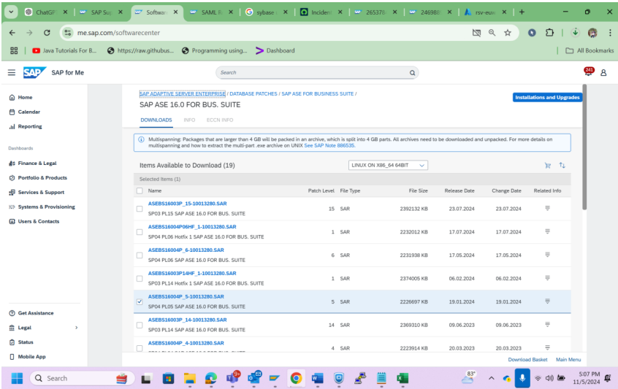

Host agent

Download software>database>SAP Adaptive Server Enterprise>database>

To check the ASE VERSION –

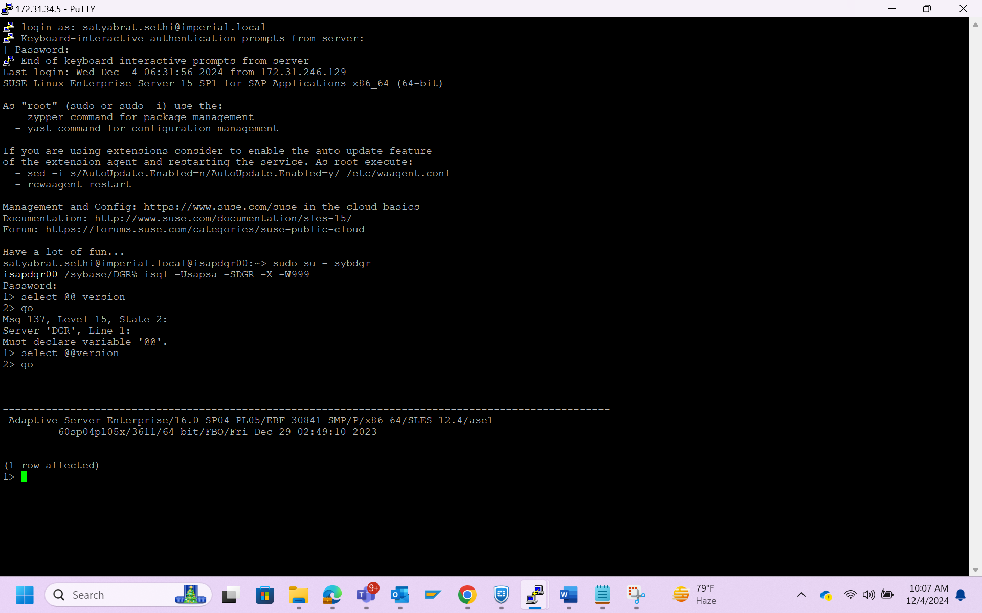

Login to sudo su – sybdgr > isql -Usapsa -SDGR -X -W999 >select @@version >go

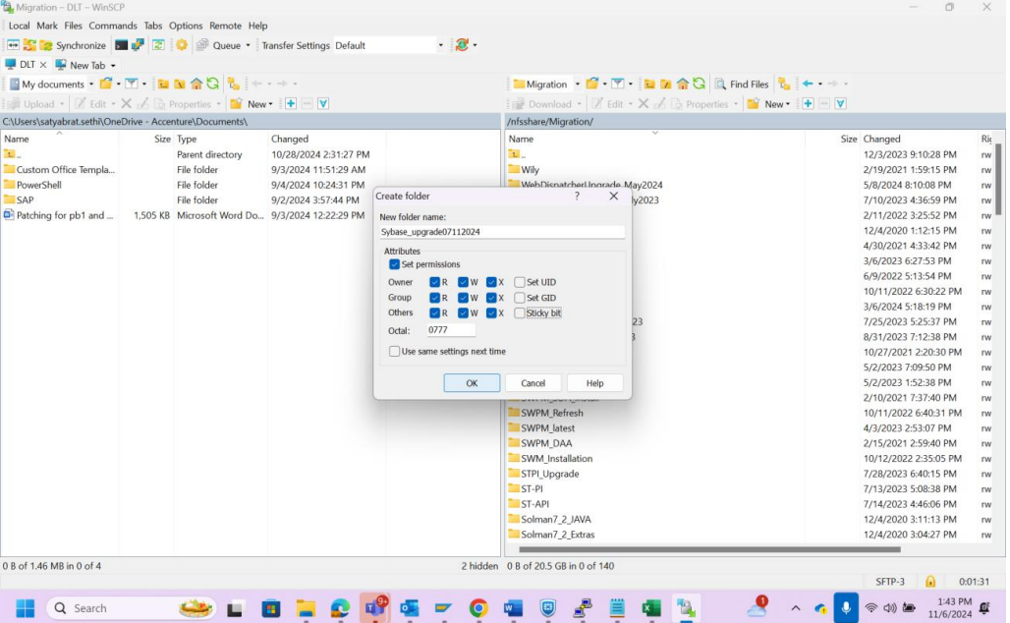

Cop the downloaded file through winscp n give full permission.

After complete the file to os .

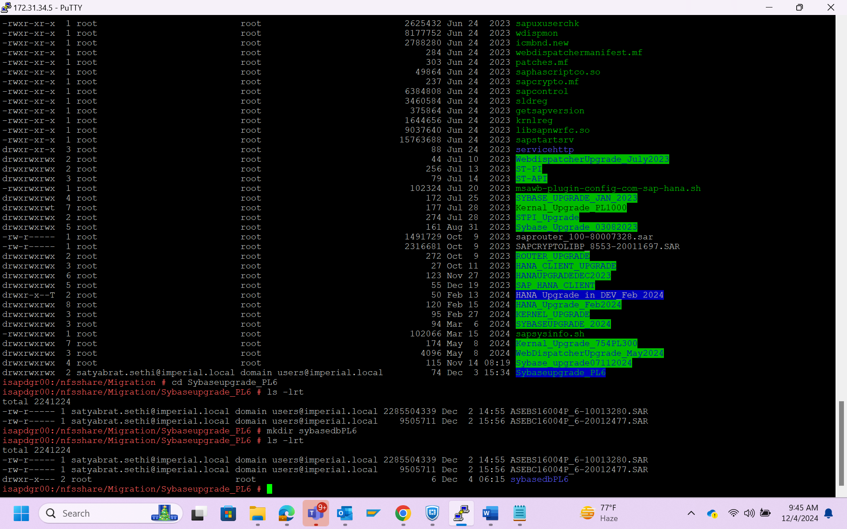

Make new folder and copy the ASE file in it.

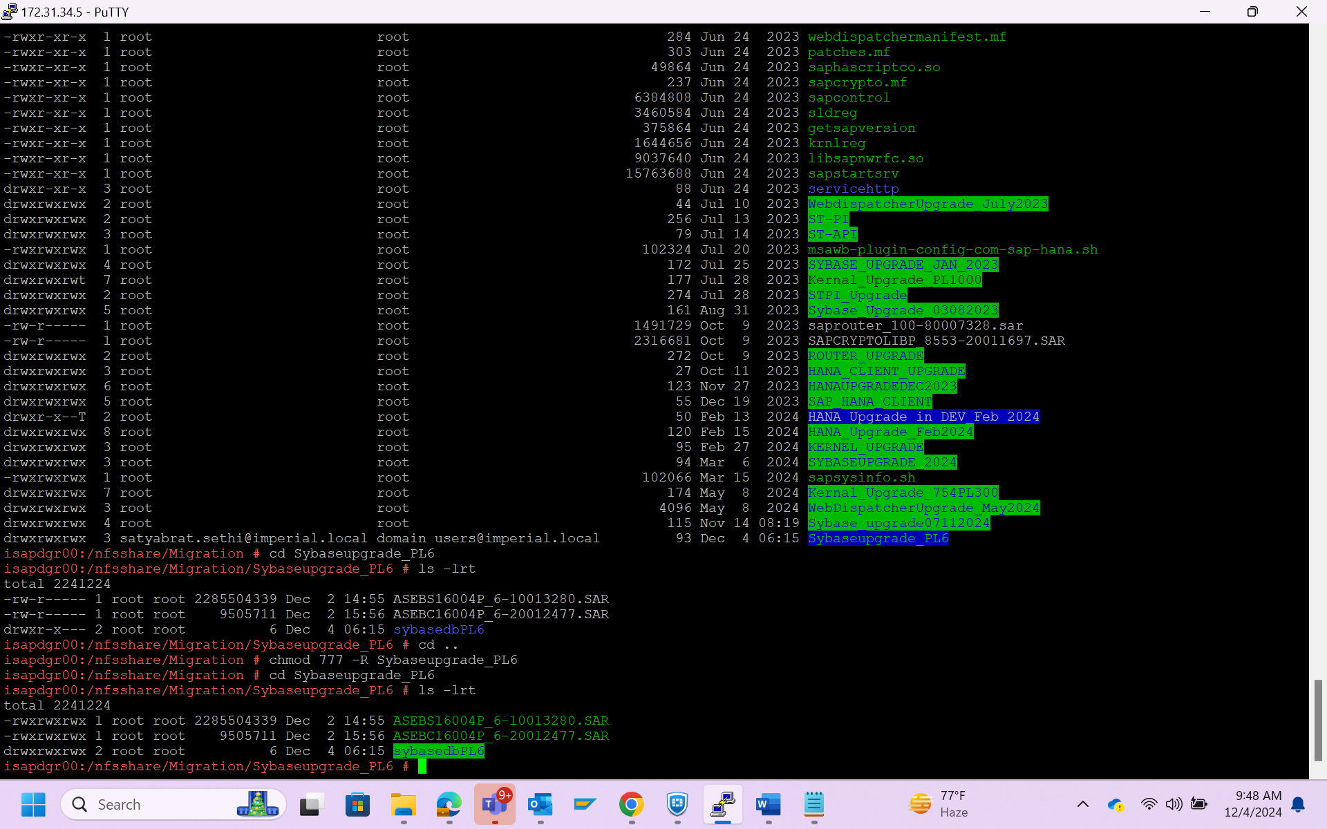

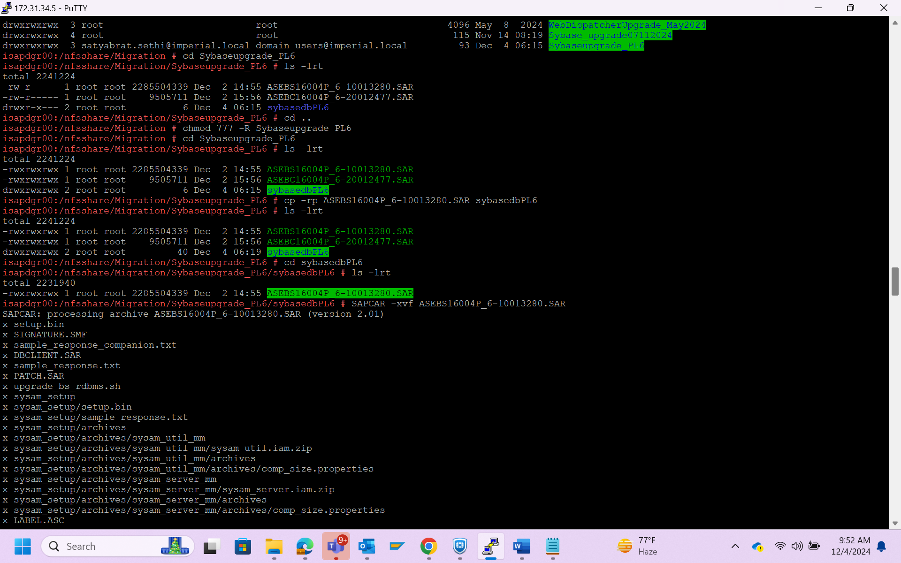

Extract of ASE file started.

Extract of ASE file finished.

Before upgrade

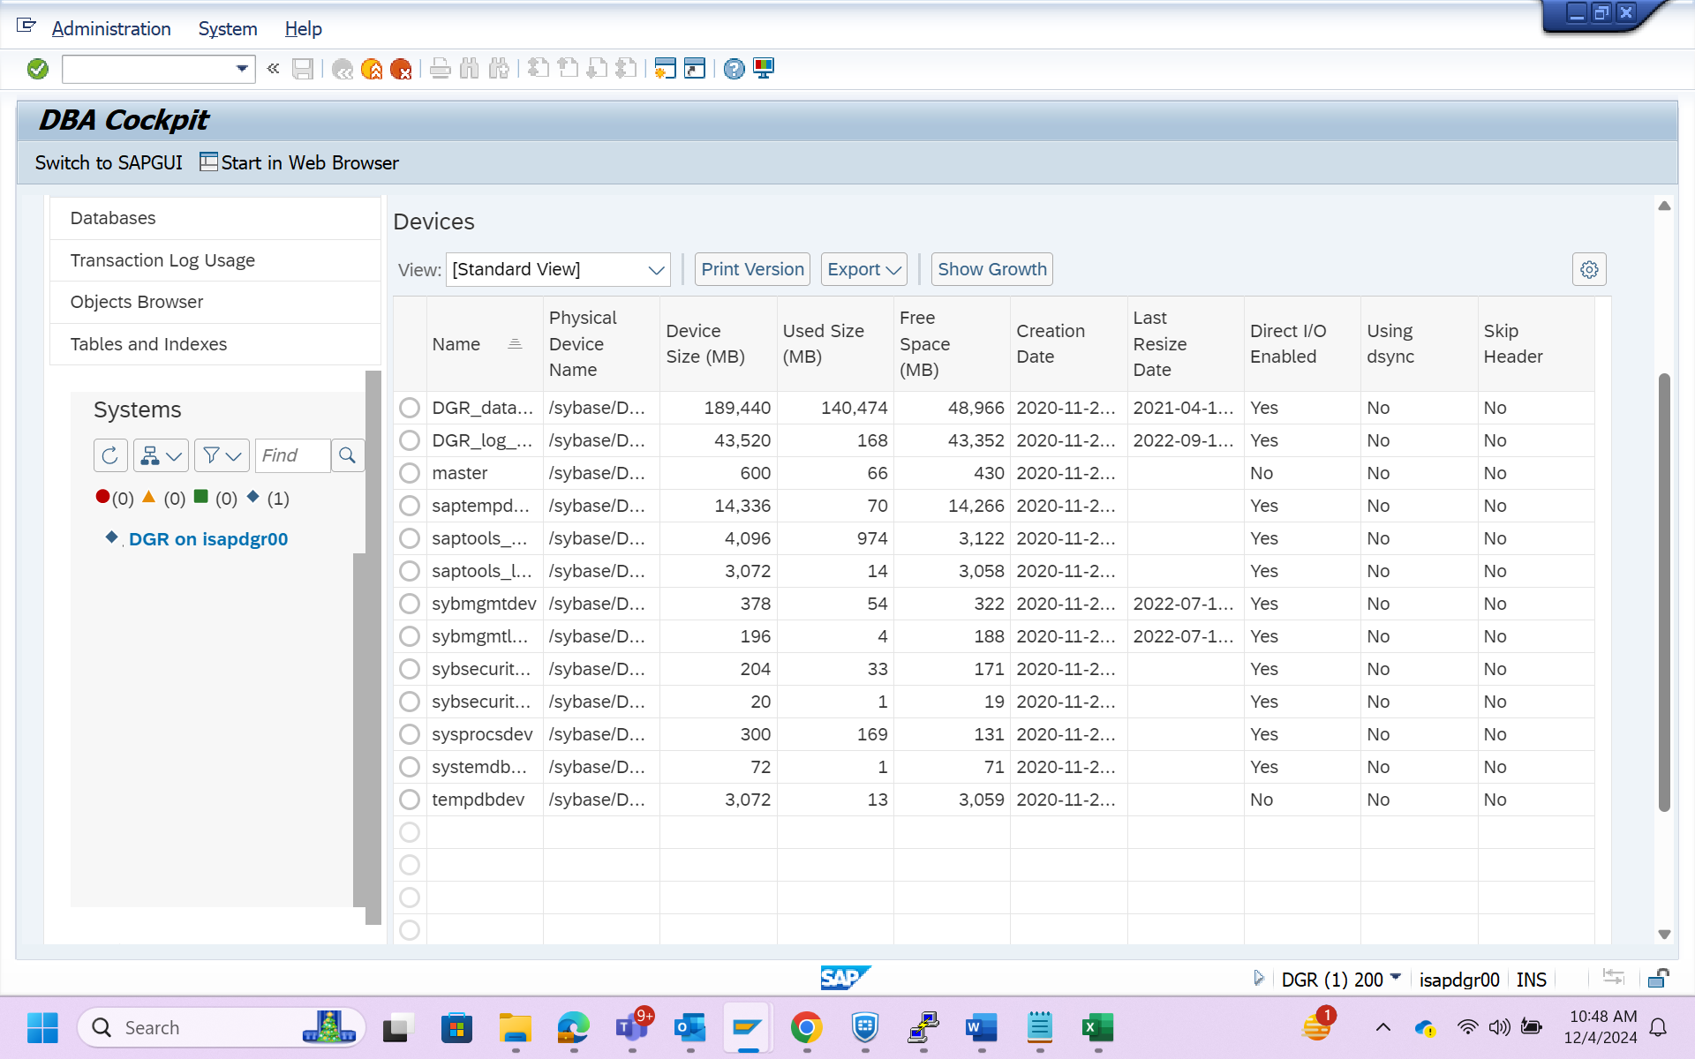

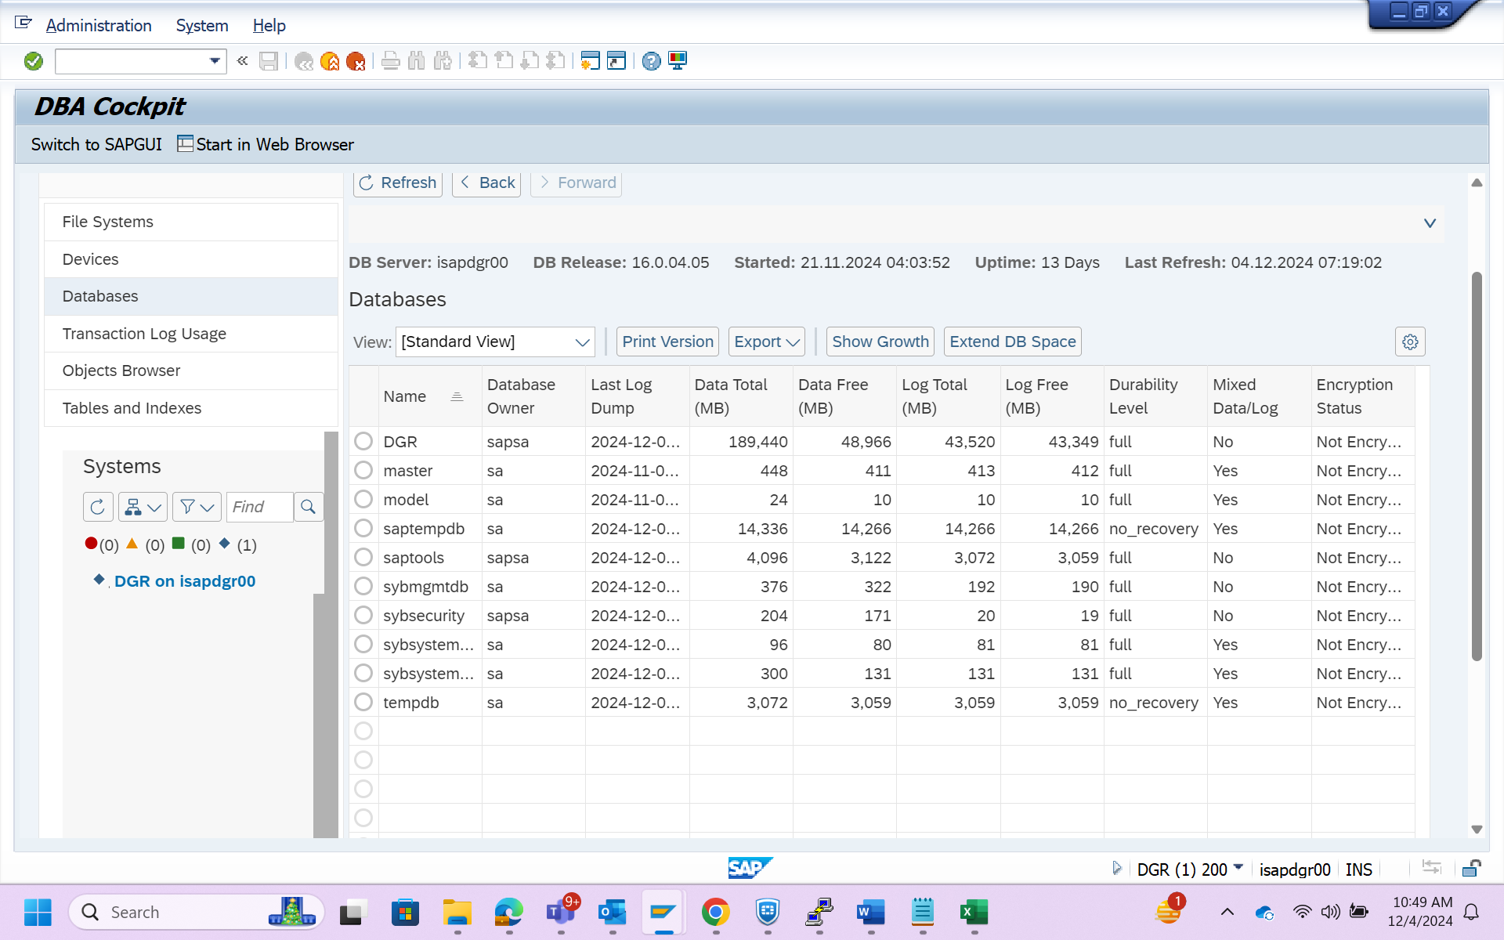

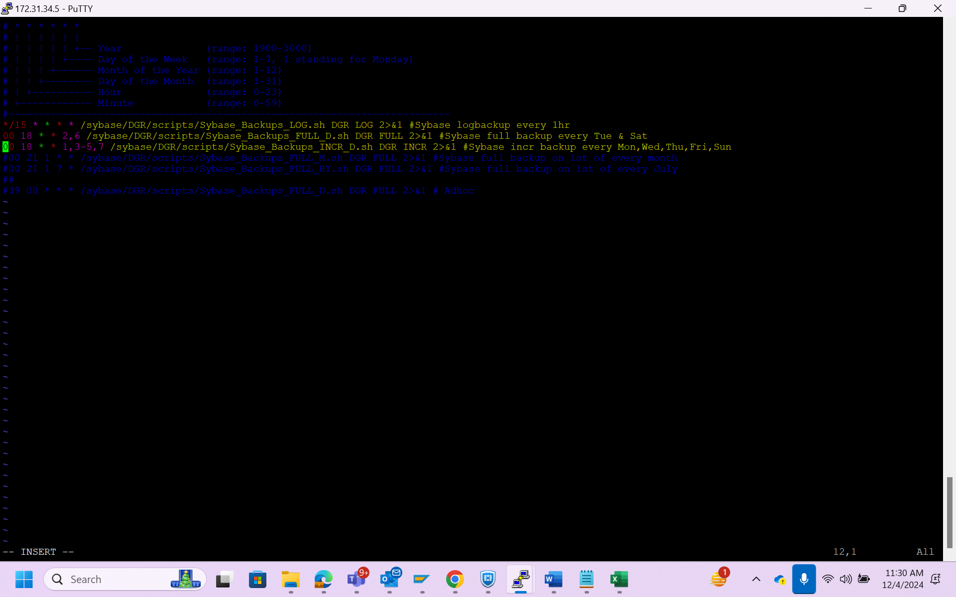

Stop the application

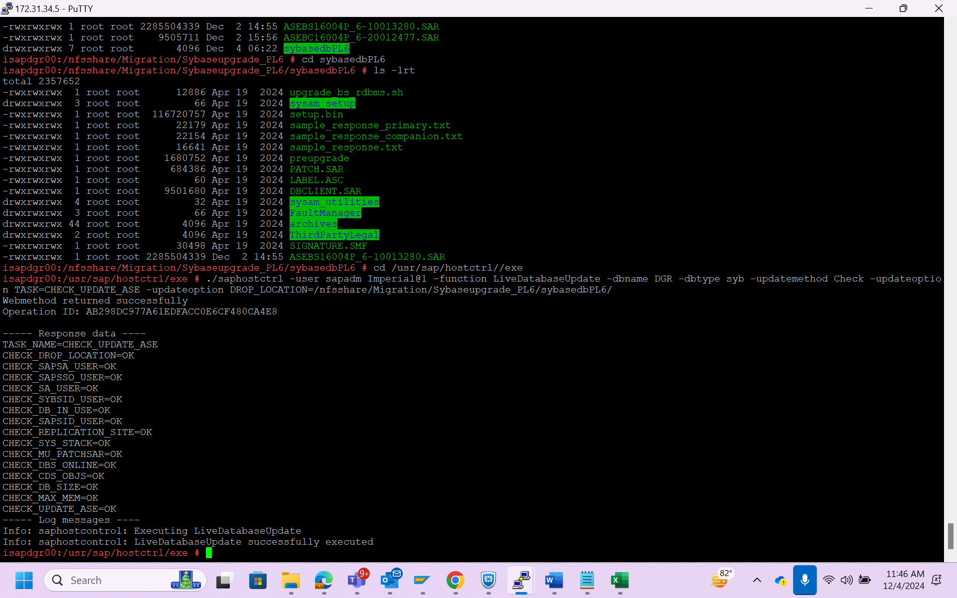

To check the command

./saphostctrl -user sapadm Imperial@1 -function LiveDatabaseUpdate -dbname DGR -dbtype syb -updatemethod Check -updateoption TASK=CHECK_UPDATE_ASE -updateoption DROP_LOCATION=/nfsshare/Migration/Sybaseupgrade_PL6/sybasedbPL6/

To update the ASE –

./saphostctrl -user sapadm Imperial@1 - -function LiveDatabaseUpdate -dbname QPO -dbtype syb -updatemethod Execute -updateoption TASK=UPDATE_ASE -updateoption UPDATE_FORCE=1 -updateoption DROP_LOCATION=/nfsshare/Migration/Sybaseupgrade_PL6/sybasedbPL6/

Before upgrade the ASE we have check >>

>Start ASE DB only dataserver (don’t start backupserver)

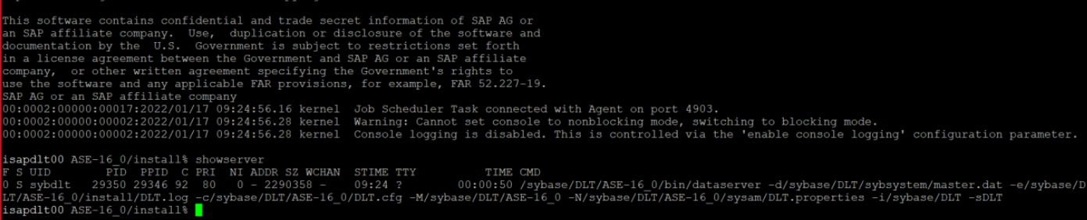

startserver -f RUN_DGR

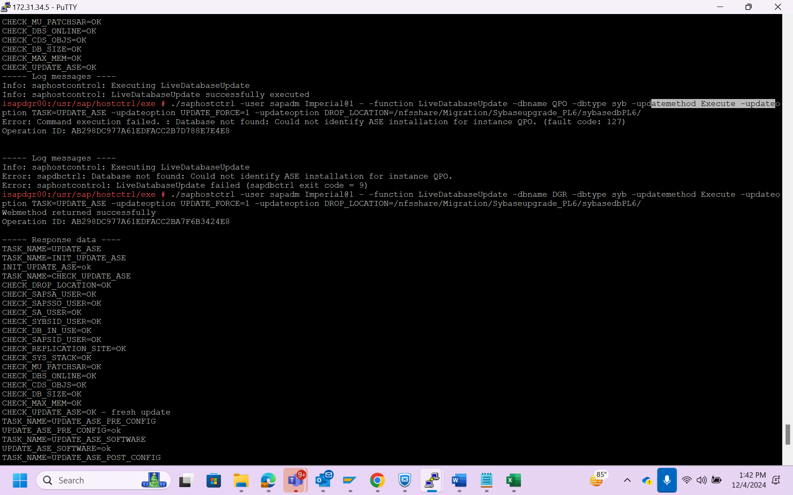

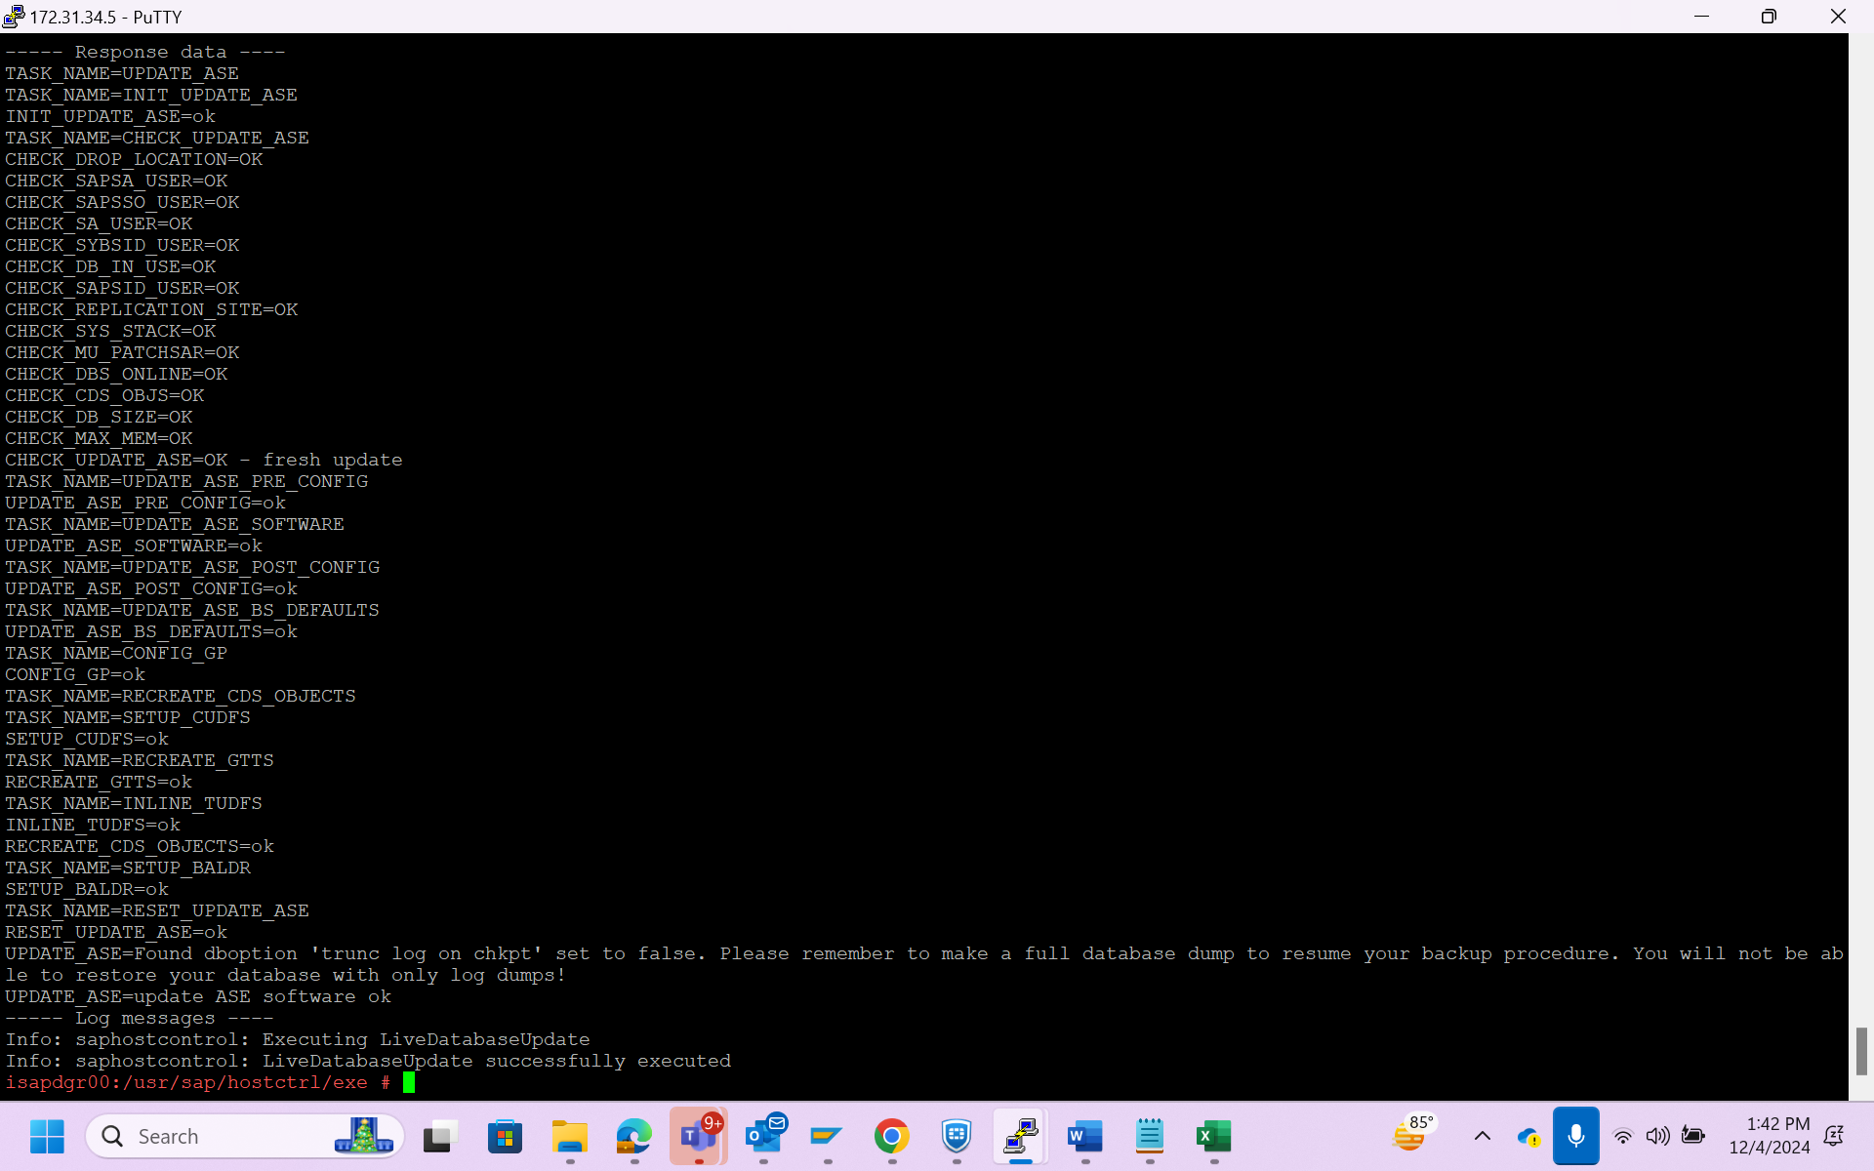

After that we have to check the db is up or not.

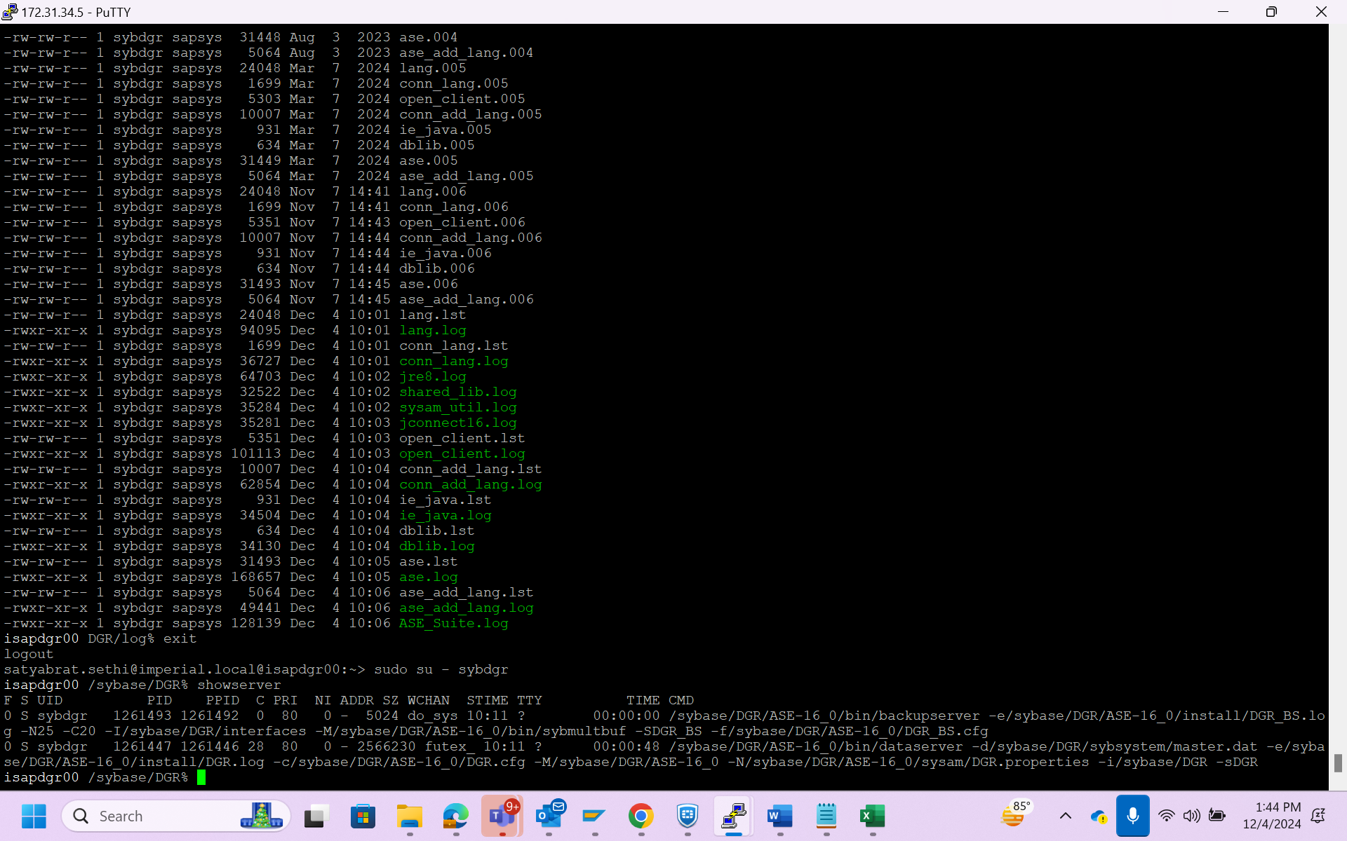

We have verify the version of system by

isql -Usapsa -SDGR -X -W999 > select @@version

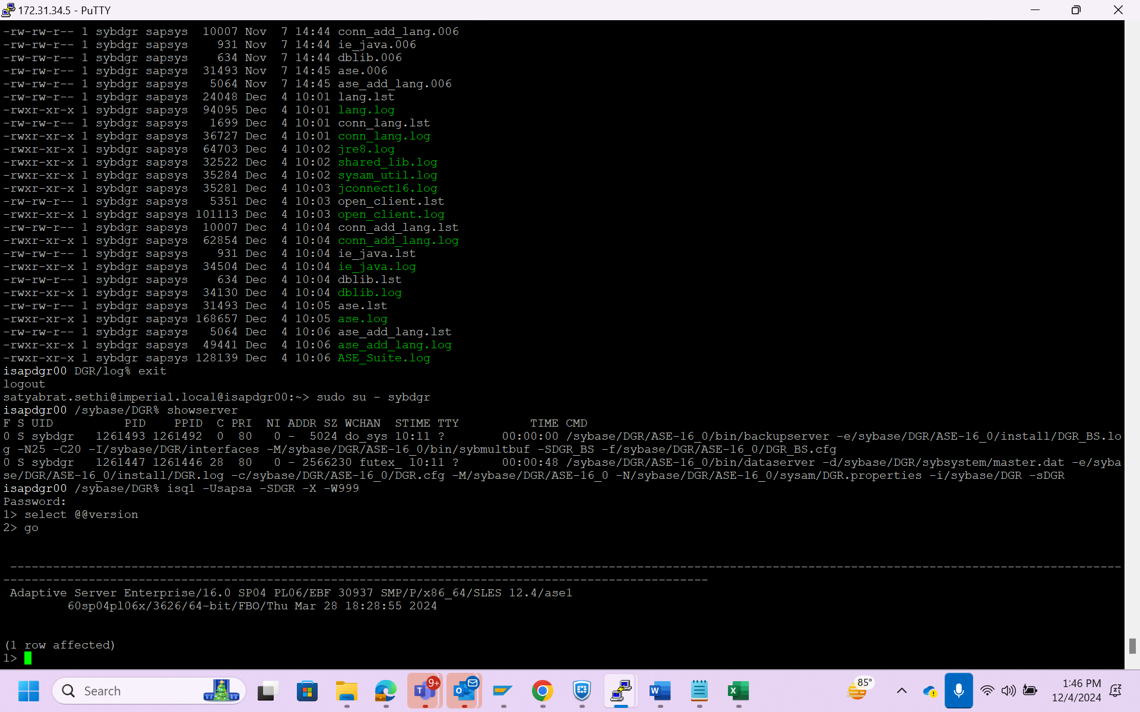

Then we have login to sidadm and run this command

1.env | grep LD_LIBRARY_PATH

2. cd /usr/sap/DGR/SYS/global/syb

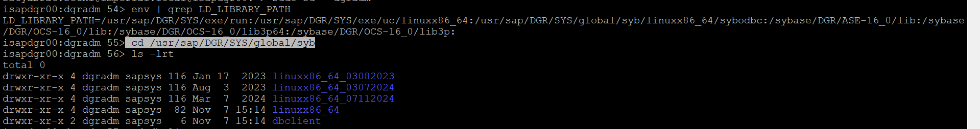

3.take a backup of linuxx86_64

4.create a new folder inside /nfsshare/Migration/Sybaseupgrade_PL6> mkdir dbclientpl6

5.change the ownership of the folder to chown -R dgradm:sapsys dbclientpl6

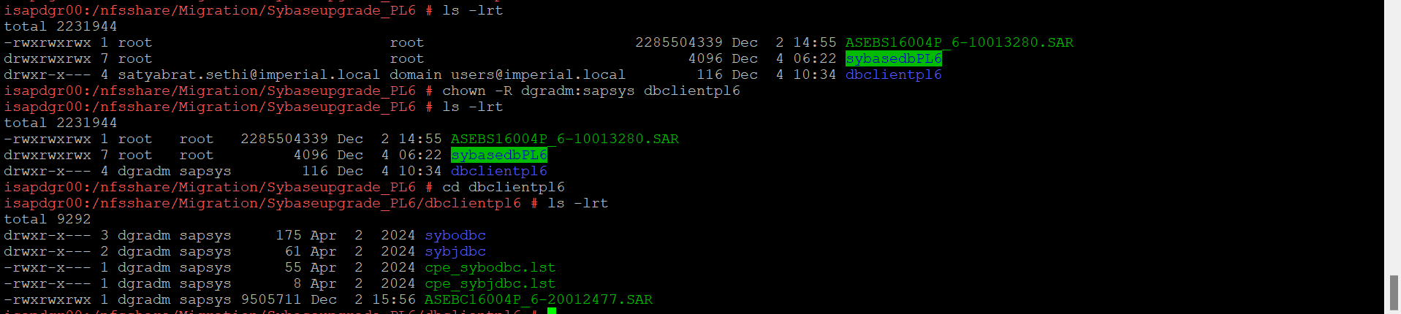

6.After that move the dbclient(ASEBC1) to /nfsshare/Migration/Sybaseupgrade_PL6/dbclientpl6

7. extract the file dbclient(ASEBC1) 🡪 SAPCAR -xvf ASEBC16004P_6-20012477.SAR

8. go to cd /usr/sap/DGR/SYS/global/syb/ linuxx86_64 and take a backup of linux86_64 and delete the old file inside

9. move the new file to /usr/sap/DGR/SYS/global/syb/ linuxx86_64:

mv sybodbc sybjdbc cpe_sybodbc.lst cpe_sybjdbc.lst /usr/sap/DGR/SYS/global/syb/linuxx86_64

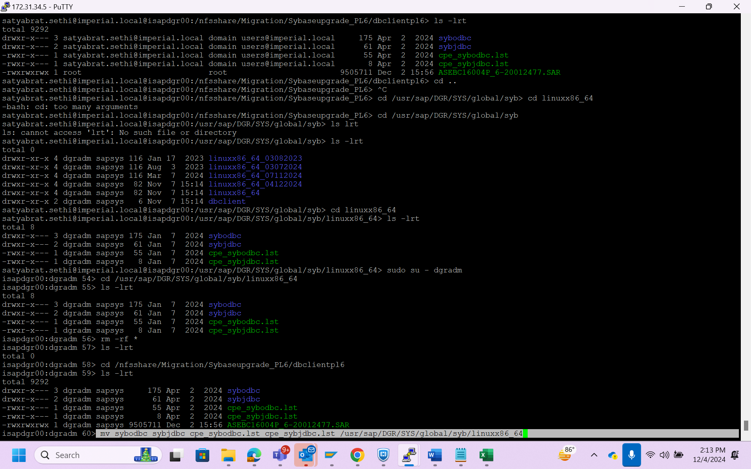

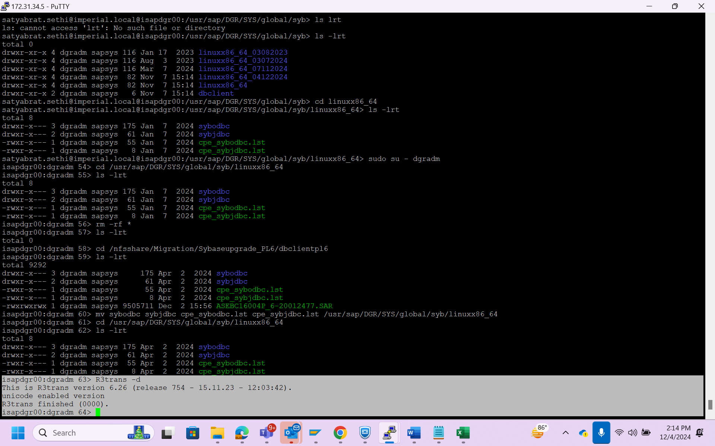

10. dbclient updated.

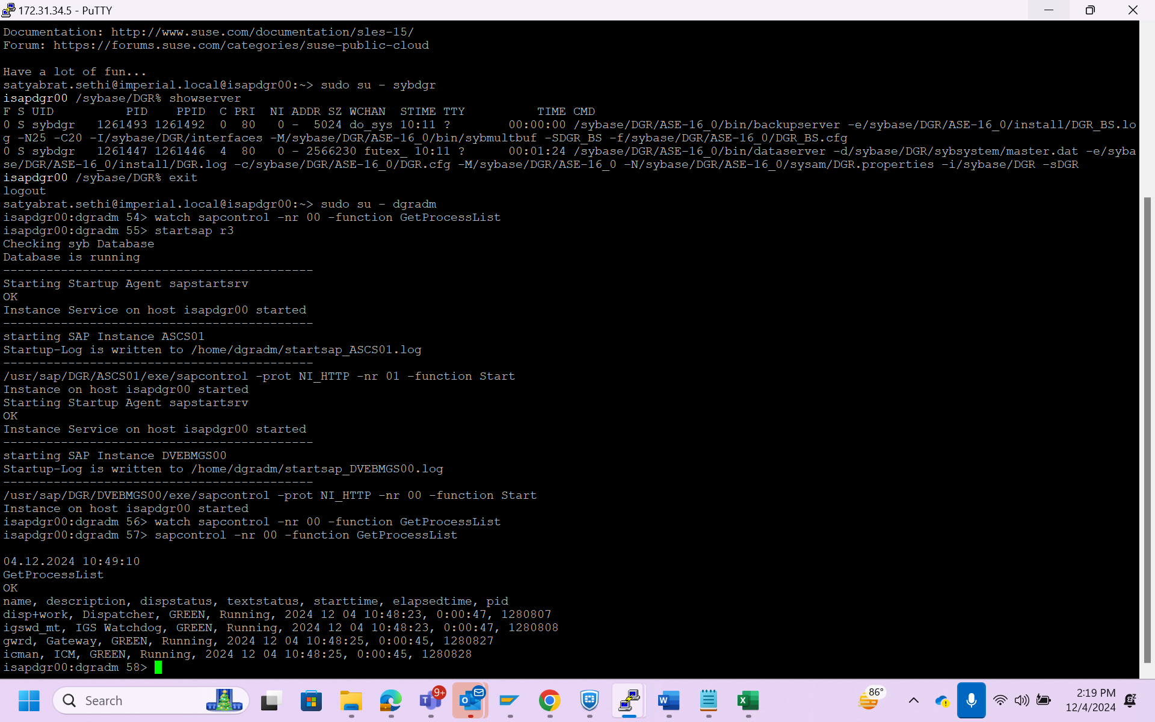

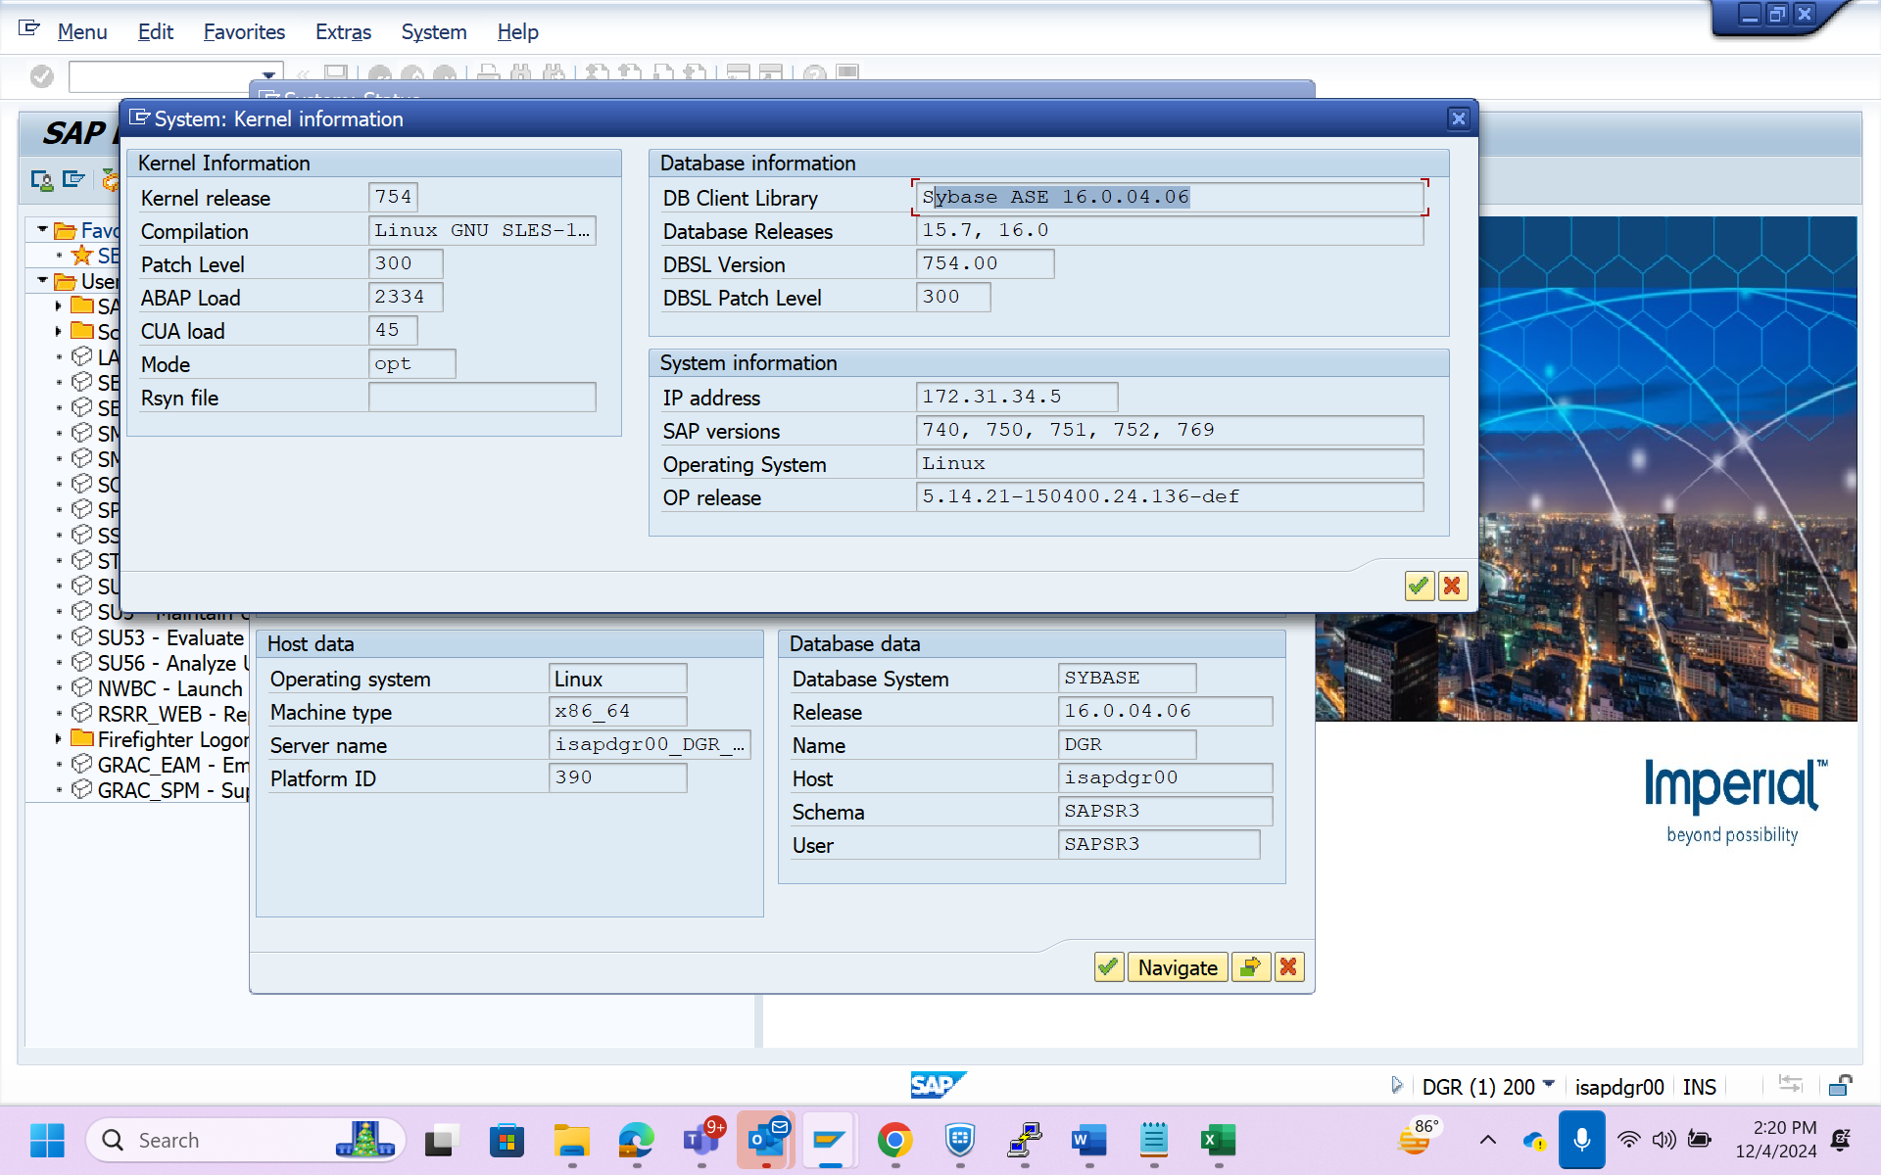

Start the crontab -e script

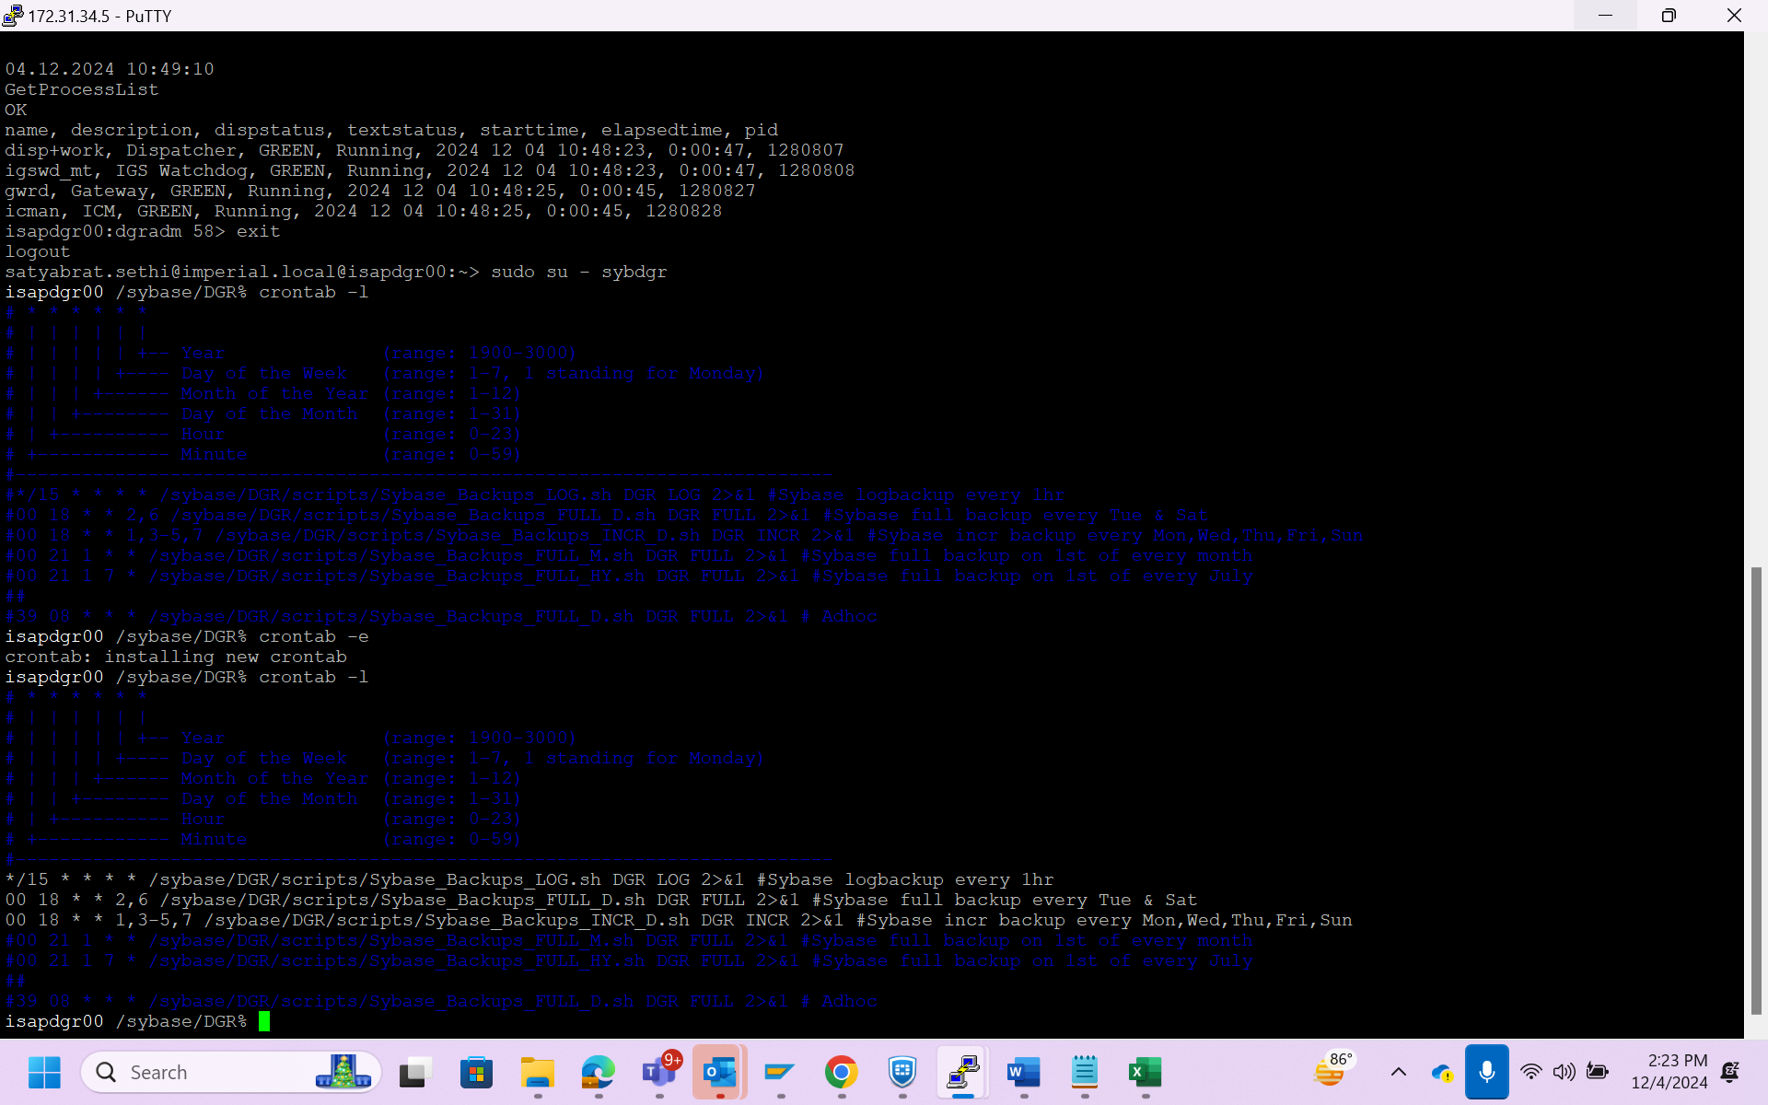

Esc :wq! >>To save